Task 2:

**Software testing life cycle - Benefits & Phases:**

Software Testing Life Cycle (STLC) is **a process used to test software and ensure that quality standards are met**. Tests are carried out systematically over several phases. During product development, phases of the STLC may be performed multiple times until a product is deemed suitable for release.

Testers follow various strategies and approaches to aim for optimum quality. One interesting process is the software testing life cycle (STLC)

* Requirement analysis
* Test planning
* Test case development
* Environment setup
* Test execution
* Test cycle closure

Testing teams may currently use the majority of these steps but  STLC allows testers to [shift left](https://blog.testproject.io/2020/08/27/shift-left-and-qa-responsibilities/) in development lifecycles because it allows testers to discover requirements, test ideas, and formulate test scenarios.

This article covers the basics of  STLC and its benefits, discusses its various phases, and walks you through the differences between STLC and Software Development Life Cycle (SDLC). Let’s deep dive into it then!

## ****Benefits of Software Testing Life Cycle (STLC)****

**Some of the STLC benefits include :**

* Increased **consistency**and **effectiveness**as project requirements are analyzed.
* **Clear and defined goals** for test products, which helps track the project’s process.
* The **confidence**in each feature passes testing before adding additional features.
* Tests are designed in a meaningful manner.
* Specifications are clear, which helps the team.
* It’s a systematic approach that quickly resolves bugs and defects in the product.

## ****What are Entry Criteria and Exit Criteria in  STLC?****

**Entry Criteria:**Entry Criteria are a set of conditions that testers must satisfy to**begin**the test.

**Exit Criteria:**Exit Criteria are a set of conditions that testers must satisfy to **end** the test.

## ****Phases of Software Testing Life Cycle (STLC):****

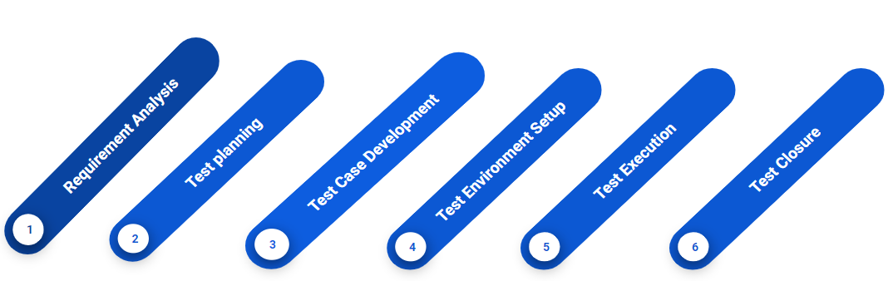

#### **Phase 1: Requirement Analysis:**

In the first phase, the STLC team understands the requirements  [testing teams](https://blog.testproject.io/2020/01/29/the-first-selenium-framework-for-team-collaboration-testproject/) may also consult with stakeholders to clarify the requirements. The requirements may be functional or non-functional and the decision to [automate testing](https://testproject.io/) is also evaluated at this point.

****Activities in Requirement Analysis:****

* Identify customer needs and types of tests to be performed.
* Gather details about requirements from the customer about the applications.
* Prepare Requirement Traceability Matrix (RTM).
* Identify test environment details.
* Automation feasibility analysis (if required).

****Deliverables of Requirement Analysis:****

* Requirement Traceability Matrix (RTM).
* Automation feasibility report (if applicable).

****Entry Criteria Requirement Analysis:**** client requirements, acceptance criteria, and intended product architecture to be documented.

****Exit Criteria Requirement Analysis:**** aim for a requirement traceability matrix (RTM) and decision of automation.

#### **Phase 2: Test Planning**

This phase includes implementing and defining a test strategy in the testing plan and estimating the efforts and costs of the testing team. This stage commences once  requirement gathering is complete.

****Test Planning Activities****

* Preparation of test plan documents for different types of testing.
* Selection of test tools.
* Test effort estimation.
* Resource planning and deciding roles and responsibilities.
* Training requirement.

****Deliverables of Test Planning****

* Test plan document.
* Effort estimation document.

****Entry Criteria Test Planning:**** Report the implemented test strategy.

****Exit Criteria Test Planning:**** Testers should have approval on the test plan’s risks and costs.

#### **Phase 3: Test Case Development**

During this phase, testers create test cases. Each case defines test inputs for data, procedures, execution conditions, and anticipated results  [automation scripts](https://testproject.io/) are also created during this phase.

****Test Case Development Activities****

* Creation of test cases and automation scripts (if applicable).
* Review test cases and scripts.
* Create test data (If Test Environment is available).

****Deliverables of Test Case Development****

* Test cases/scripts.
* Test data.

****Entry Criteria Test Case Development:**** Approval of timelines to execute the test plan.

****Exit Criteria Test Case Development:**** Approval of test cases and automation scripts.

#### **Phase 4: Test Environment Setup:**

In the fourth phase, a [QA/Testing environment](https://blog.testproject.io/2020/08/26/the-importance-of-a-qa-environment/) is configured and deployed to allow testers to test the feature. Once the testers deploy the environments, [smoke testing](https://blog.testproject.io/2020/05/31/smoke-testing-vs-sanity-testing/) may be performed to ensure the environment is working with the intended functionality ✅.

****Test Environment Setup Activities****

* Testers must keep the test environment ready by understanding the required architecture, environment setup, and preparing a hardware and software requirement list.
* Setup test environment and test data.
* Perform a smoke test on the build.

****Deliverables of Test Environment Setup****

* Test Environment ready with the prepared test data.
* Smoke Test Results.

****Entry Criteria Test Environment Setup:**** Have a defined system design and project architecture.

****Exit Criteria Test Environment Setup:**** Have a working QA/Testing environment set up to run test cases.

#### **Phase 5: Test Execution:**

In the fifth stage, testers begin the test execution as the environment is successfully set up. The test cases generated at phase three are put into action here and previously expected results may compare to the actual results as a baseline. Testers may also report back interesting findings, such as [bugs,](https://blog.testproject.io/2020/11/02/tricks-to-write-a-good-bug-report/) to the development teams.

****Test Execution Activities:****

* Execute test cases according to plan.
* Generate a test report and log defects for failed cases.
* Map defects to test cases in RTM.
* Perform Retest.
* Track the defects to Complete the test.

****Deliverables of Test Execution****

* Completed RTM with the execution status.
* Test cases updated with a pass or fail results.
* Defect reports.

****Entry Criteria Test Execution:**** Have all the previous steps completed, especially the exit criteria.

****Exit Criteria Test Execution:**** Document test execution and results to report them back.

#### **Phase 6: Test Closure**

In the last stage of the STLC, a [test result report](https://testproject.io/executive-test-reports/) is generated. The report should contain the entire process of testing new requirements such as the analysis between the expected outcome and the actual outcome, whether the objectives were met or not, the time taken to test the feature, costs, test coverage, and if there were any defects and details about it.

### **Test Closure Activities**

* Evaluate test cycle closure completion criteria based on Time, Test coverage, Cost, Software, Critical Business Objectives, and Quality metrics.
* Prepare test metrics based on the above parameters.
* Prepare Test closure report.
* Test result analysis to find out the defect distribution by type and severity.

****Test Closure Activities****

* Test Closure report.
* Test metrics.

****Entry Criteria Test Closure:**** Test results and logging from the previous phases.

****Exit Criteria Test Closure:**** Delivered planned deliverables (delivered planned deliverables use too much of the same word. Try to add a different one) and approved test closure test summary report.

## **STLC vs. SDLC: How Do They Differ?**

Although  STLC (Software Testing Life Cycle)and SDLC (Software Development Life Cycle) might seem related, they are different because they both have different aims and guidelines.

Something quite interesting is that STLC phases during SDLC, SDLC is related to **software development**and STLC is related to **software testing**. STLC is a segment/subset/part of SDLC. Testers execute the activities in both lifecycles are executed one after the other.

Another difference between both approaches is that  SDLC’s primary goal is to collect the client requirements and create the features accordingly.

The goal of SDLC is to complete successful software developments with quality software. Conversely, STLC aims to complete successful software testing activities and make the software defect-free. Both STLC and SDLC phases must complete entry and exit criteria before entering or leaving any previously mentioned phase.

In both of these approaches, you need your stakeholders such as DevOps, testing team, Product owners, Business analysts, and developers. Full cooperation from the team in both approaches means you may verify the requirements, tests, and form accurate results.

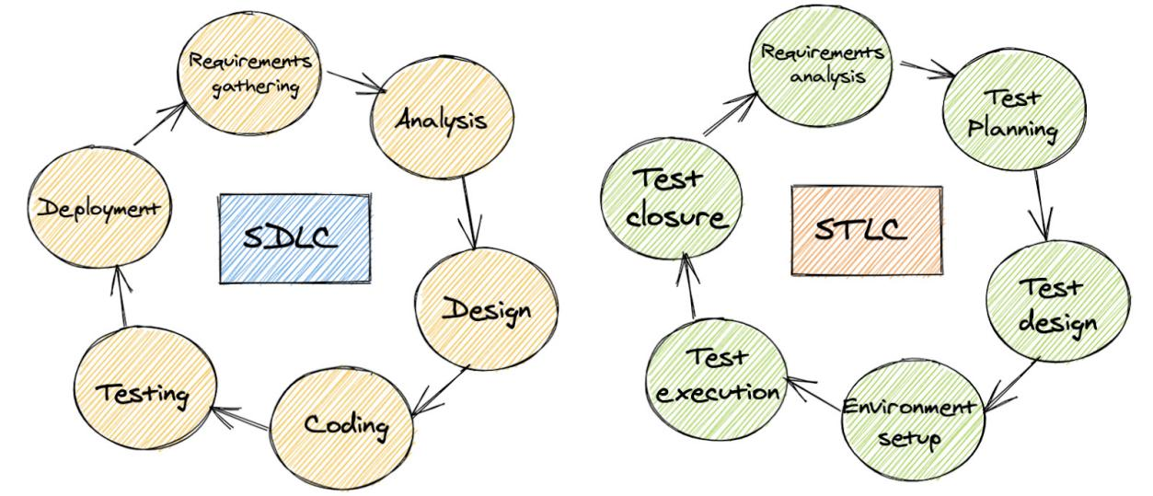

## **When to Stop Testing?**

This is a very interesting question, it’s a question that gets asked around a lot too. Testing should be stopped **when it meets the exit criteria put in the test plan**. Test managers, leads, clients, and respective stakeholders will consider all factors to decide when to stop.

## **The Importance of Reporting**

When teams  complete a release, they have generated release notes and when they complete STLC phases they generate a [test report](https://testproject.io/executive-test-reports/). This report will highlight testing outcomes, evaluations, and may be used as a document to improve confidence to release the application or not.

It is vital to generate this report and not feel like the job is done. It is better to learn from it and see how the test strategies used this time could be implemented or improved in the future

At the end of the day we are aiming for a good quality product, therefore aim for removing bottlenecks and continue with the best practices for next time.